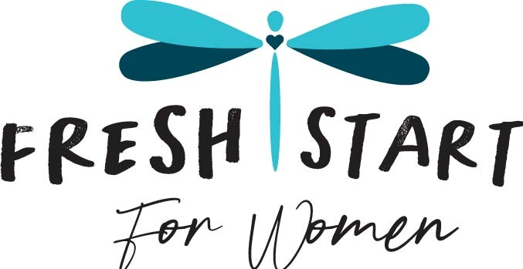

Fresh Start for Women 2025 Grant
Letter Date: 09/09/2025

Dear Impact 100 Committee,
On behalf of Fresh Start for Women, I would like to express our gratitude for your ongoing commitment to strengthening our community and supporting organizations that bring hope and transformation to individuals in need. We are excited to share with you the details of our 2025 grant request and the vital role it will play in the lives of the women and children we serve. In early 2025 we found we were in violation of city codes by utilizing our community room in its current condition.

Our community room has been at the heart of life at Fresh Start for Women where healing, learning, and connection can take place. Throughout the week, it has been utilized for a variety of purposes including classes such as, life skills, book studies, and recovery classes. Mothers will also use it as a quiet space to read or study, children enjoy movie nights, and families come together for communal events. It has also been a place of fellowship where we invite other women’s groups to join us, share life together, encourage one another, and build meaningful relationships.
For women who have endured trauma, abuse, or struggled with addiction, the opportunity to engage socially and rebuild trust in community is critical. Creating healthy relationships outside of shared struggles helps our residents grow in confidence, resilience, and hope. The community room has been the backdrop for many beautiful moments of connection and healing including:
- Easter celebration and egg hunt for 33 children (current and former residents)
- Seasonal traditions such as pumpkin carving, crafts, and family dinners
- A New Year’s Eve sober party to celebrate recovery in a safe way
- Kids’ classes on health and self-care
- Support groups and educational classes on addiction and codependency
- Bible studies, game nights, and more
Unfortunately, due to building code requirements, our community room can no longer be used until necessary renovations are completed. To bring it up to compliance and expand its functionality, we must add a Handicap compliant bathroom and kitchen area as well as Fireproofing the building. Without these updates, we are unable to provide this essential space for our residents’ daily activities and life-building events.
Project Summary:
The Fresh Start for Women 2025 project seeks funding to renovate and upgrade our community room to follow local building codes including but not limited to adding a bathroom and kitchen area. This project will restore access to a critical community space (currently unusable) for our women and children, giving them the opportunity to continue growing in community, building healthy relationships, and finding encouragement and stability.
Project Budget
- Amended Site Plan for City Permit: $4,600.00
- Kitchenette, Handicap Compliant Restroom and
Fireproofing the building: $75,000.00
- Plumbing moved to new building: $19,776.00
- Appliances and Furnishings: $15,000.00 ● Drainage and Concrete: $25,000.00

Total Project Budget: $139,376.00
We believe that investment in this space will have a lasting impact—not only for current residents but also for future families who come through our program seeking healing and transformation. With your support, we can reopen the doors of our community room and continue fostering a safe, supportive, and inspiring environment for women and children to thrive.
Thank you for considering our request and for your unwavering dedication to creating positive changes. We look forward to the opportunity to partner with Impact 100 to make this vision a reality.
With gratitude,
Cindy Jean, Executive Director
Fresh Start for Women

